**Vitis Setup**

Create a platform project

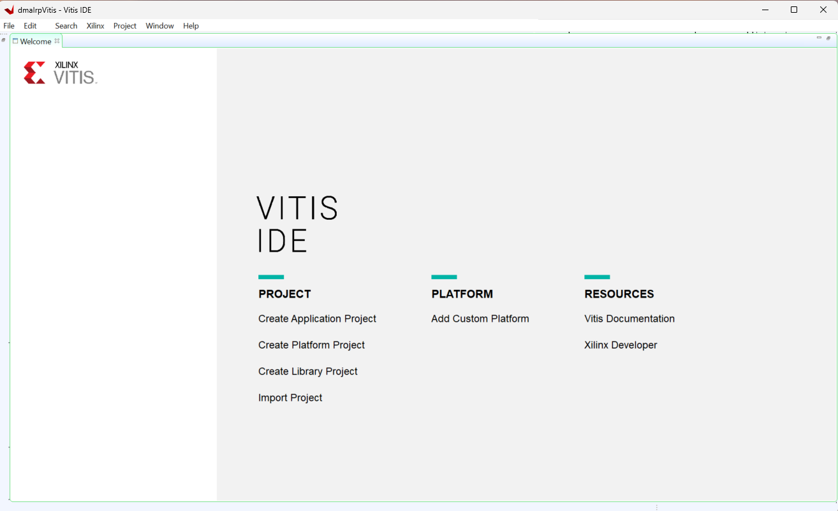

Select the .xsa file generated by Vivado

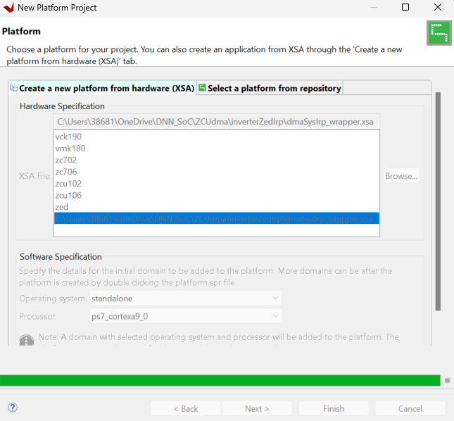

Build Platform project

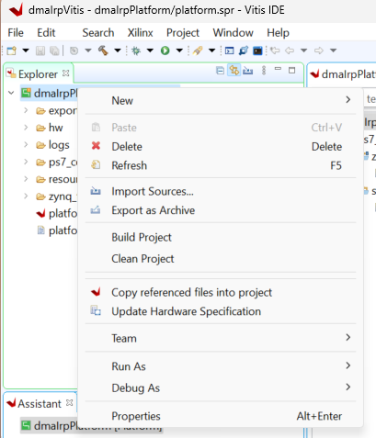

Create application project

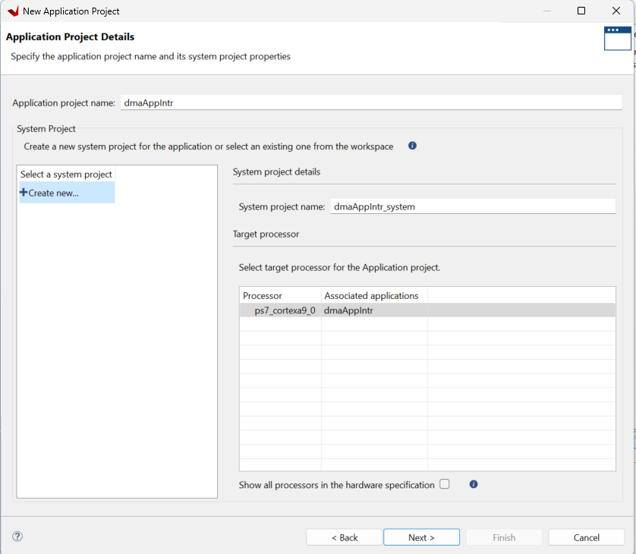

Select “**Hello World**” from templates

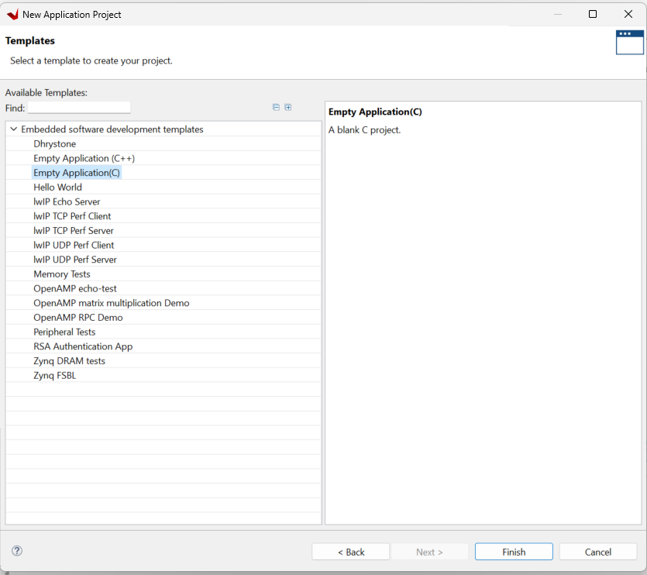

Firmware development…

Build System project

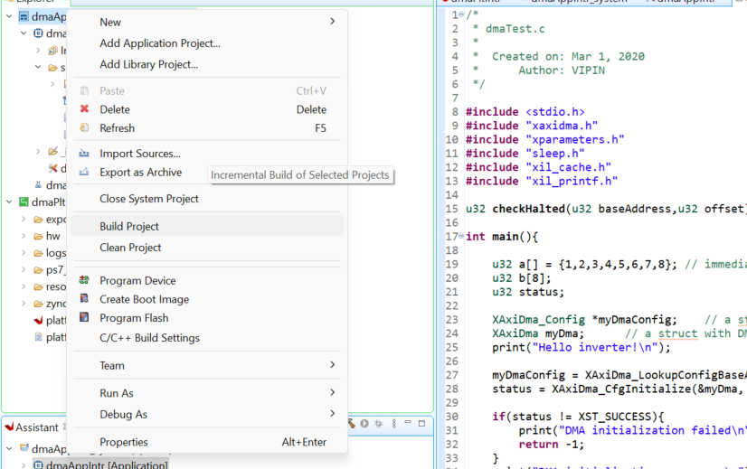

Power the board, connect with jtag

Select Application project, debug as single core, launch hardware

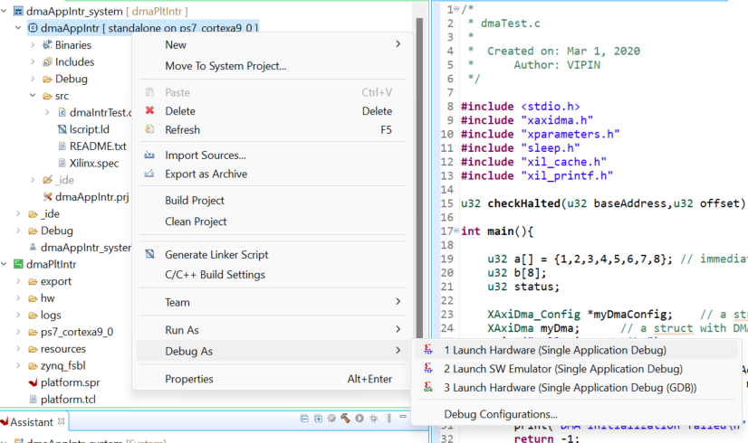

The program will pause at the automatic breakpoint at the entrance of main function, set up serial port terminal

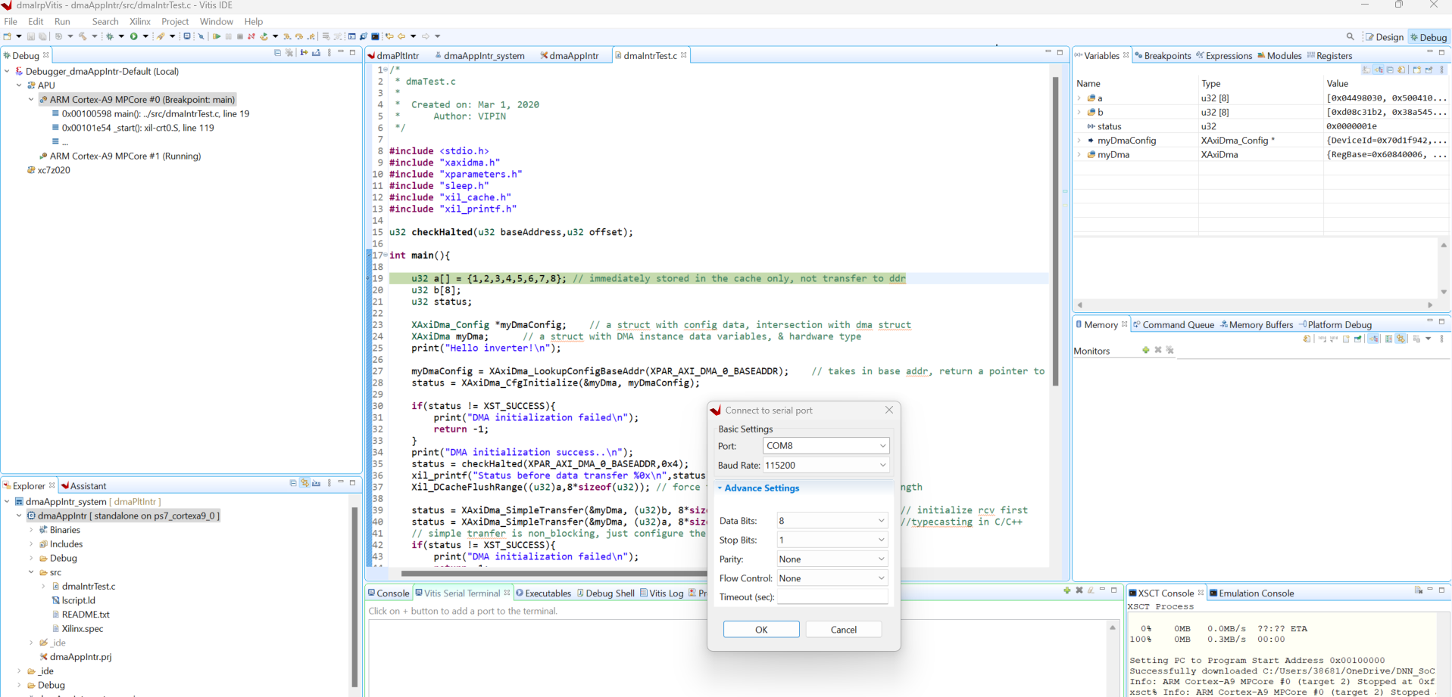

Press the continue button

The program would pause again here,

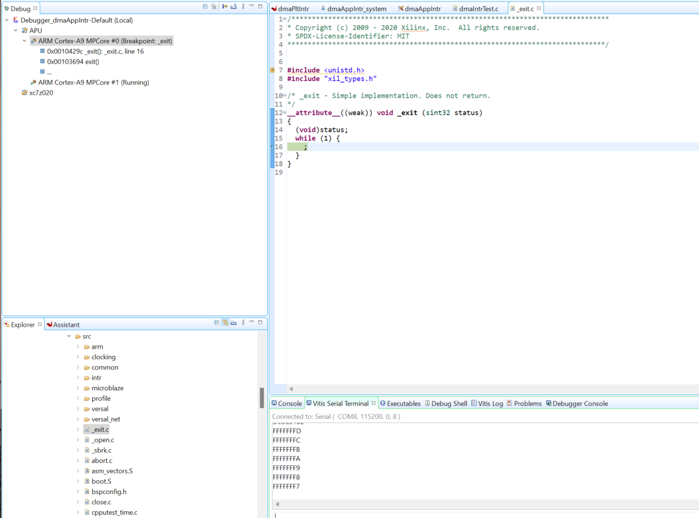

To run again (relaunch) or modify the firmware, disconnect first (also available in the top bar),

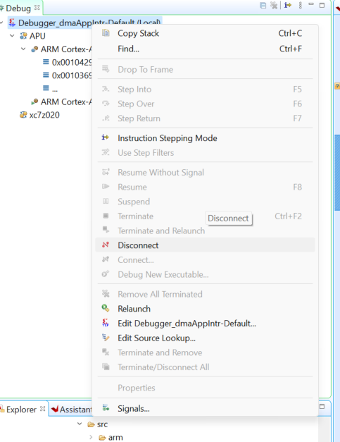

To re-run, click Relaunch.

To modify firmware, click “Remove all terminated”, and follow the same steps from launching debug.